FACT Oregon All Ability Tri4Youth Virtual Family Fitness Challenge

Activity Log Directions:
- Register for the Virtual Challenge (https://runsignup.com/allabilitytri4youthvirtual).
- Save this form to your computer, phone or Drive and complete the following fields:
Name of Participant(s): Click or tap here to enter text.
Mailing address: Click or tap here to enter text.
Email or phone: Click or tap here to enter text.
- Choose and complete 10 different activities by October 1, 2022.
- Mark complete activities with an X in the checkbox. If “other,” write a short description.
- Email completed form(s) to tri4youth@factoregon.org, or mail it to FACT Oregon, 2475 SE Ladd Ave., Ste 430, Portland, OR 97232.
- We’ll send you some cool gadgets and a t-shirt, per your request when you registered.
Activity Type | Choose Your Activity
Run 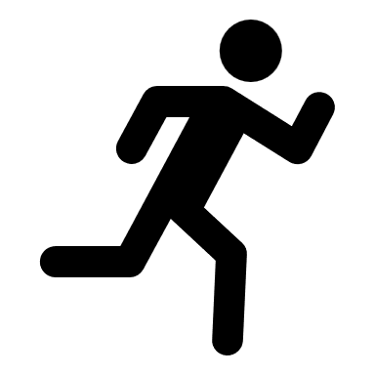 | ☐Run in place for 250 steps  ☐Do 2 sets of 25 knee lifts (raise knee to elbow)  ☐Run outside for 2.5 miles  ☐Other: Click or tap here to enter text.
Bike 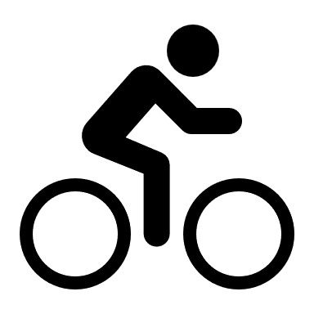 | ☐Bike/wheel/scoot for 25 minutes  ☐Pedal your legs or arms in the air 250 times  ☐Take a family bike ride!  ☐Other: Click or tap here to enter text.
Swim | Water | ☐Do 250 front crawl arm strokes in the air  ☐Run through a sprinkler 250 times  ☐Swim at the local pool  ☐Other: Click or tap here to enter text.
Pull | Push | ☐Pull/push a wagon or shopping cart for 25 minutes  ☐Do 25 pushups  ☐Pull on an exercise band 250 times  ☐Other: Click or tap here to enter text.

Activity Type | Choose Your Activity
Climb | ☐Walk/scoot up a flight of stairs 25 times  ☐Do a forearm crawl across the the room  ☐Climb on a jungle gym or rock wall  ☐Other: Click or tap here to enter text.
Squeeze | ☐Squeeze a ball between knees 25 times  ☐Squeeze water out of a washcloth 25 times  ☐Make fresh-squeezed lemonade  ☐Other: Click or tap here to enter text.
Swing | Rock | ☐Swing a bat or golf club 25 times  ☐Rock side to side 25 times  ☐Swing your arms front and back for 25 minutes  ☐Other:
Stretch 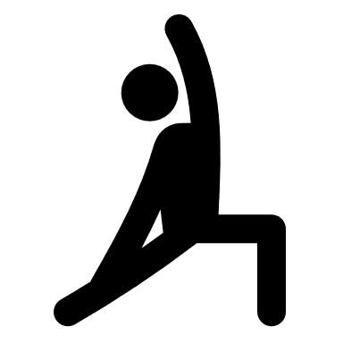 | ☐Hold 3 different stretches for 25 seconds each  ☐Play "Head, Shoulders, Knees and Toes"  ☐Take a yoga class  ☐Other: Click or tap here to enter text.
Free Play | ☐Play frisbee, tag, or ring toss with friends  ☐Play with friends at the local park  ☐Go Geo Caching or Letter Boxing  ☐Other:
Jump | Bounce 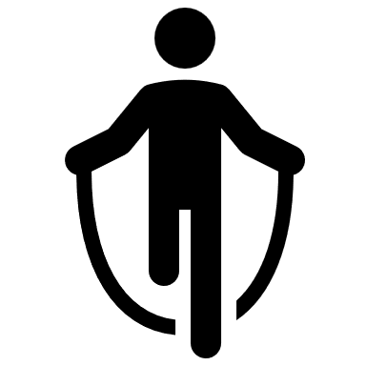 | ☐Jump or bounce 250 times  ☐Play hopscotch  ☐Jump at a trampoline park  ☐Other: Click or tap here to enter text.
Dance | ☐Dance to your favorite songs for 25 minutes  ☐Learn a new dance move on TikTok  ☐Take a community dance class  ☐Other:
Walk | Roll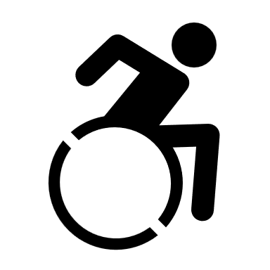 | ☐Walk or roll outside for 25 minutes  ☐Go on a 2.5 mile hike  ☐Do a Park Roll or Stroll event  ☐Other: Click or tap here to enter text.

